Media Organiser - Documentation

Running the Program

Provided in this folder are both the source code, under the directory fileExplorer, and a runnable .jar file. The .jar file once ran will ask for a directory. An example directory I have set up is the mediaFiles directory, also found here. This contains an example json save file, however to test from scratch this can be deleted before the file is run.

Limitations

One limitation I found about using Java was the difficulty in creating a user interface. The user interface does seem quite rigid and unyielding, which lead to me running into a few difficulties, especially with form organisation.

Another limitation of my implementation I discovered was using file paths as the unique identifier for files. This meant that any time a file was moved, I had to update multiple places that referenced that image. I don;t believe this caused too much of an issue later on.

Future Improvements

One improvement I would like to have made if I had had the time would be improving the user interface. Although functional, it is possible that it could lead to some confusion, especially with the category sections being near identical, with the only thing separating the Add / Remove category from the Add / Remove category from file, being the side of the page the section was on.

Another improvement I would like to have made is adding a more extensive search ability, with the current one only allowing the user to search by media file types, and in a very rigid way. The improvement I would make given the time would be to make the search easier to use, adding the ability to search file names, including using wildcards.

User Guide

To initialise the media organiser, open the program and enter the full directory path into the provided box. Clicking ‘OK’ will then initialise the file explorer.

To organise your files into categories, your first task will be to create one or more category. This can be done by clicking the ‘Add’ button under ‘Categories’ on the left toolbar, as shown below.

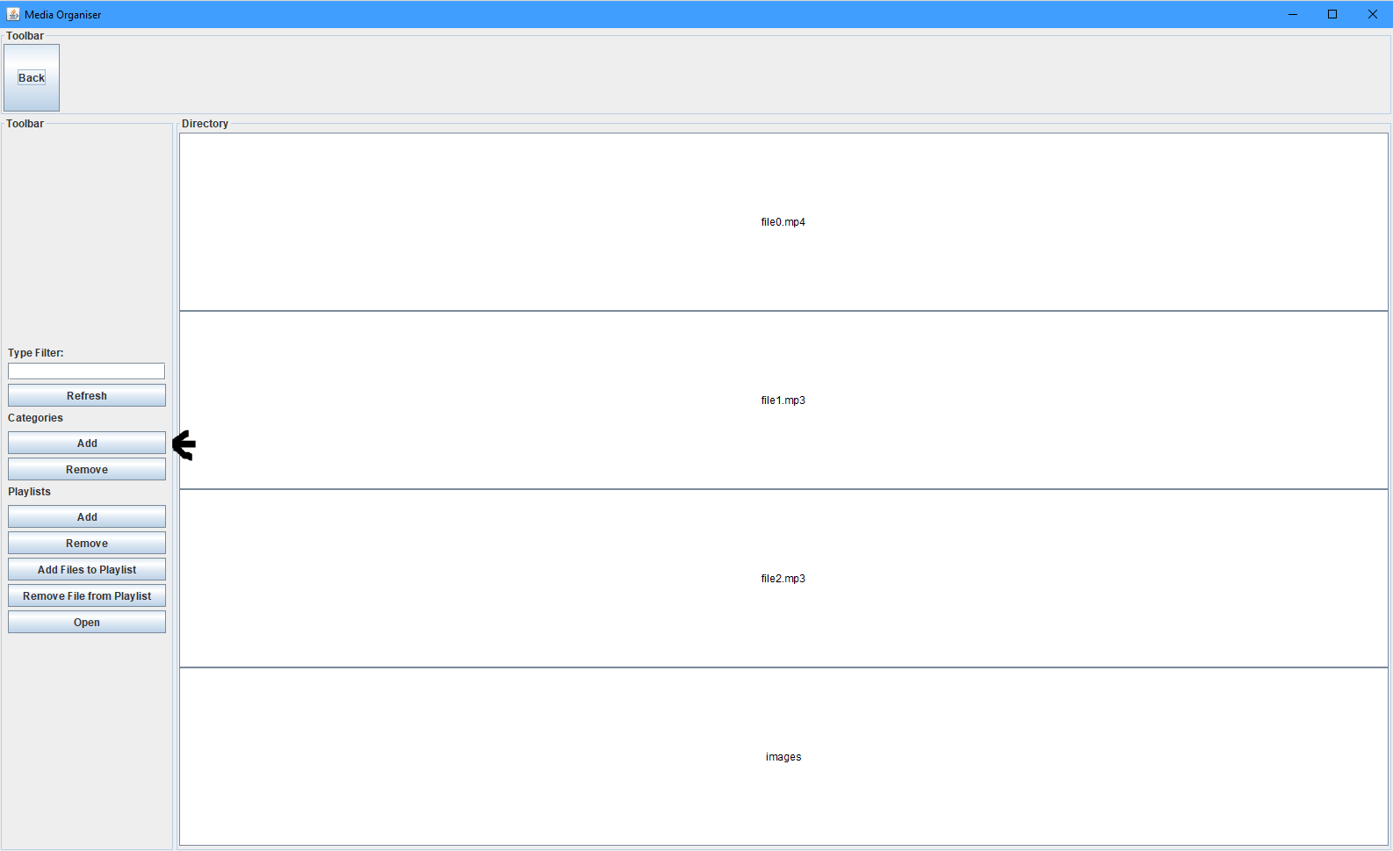

This will then show the pop up shown below. Simply enter the name of the category and press ‘OK’.

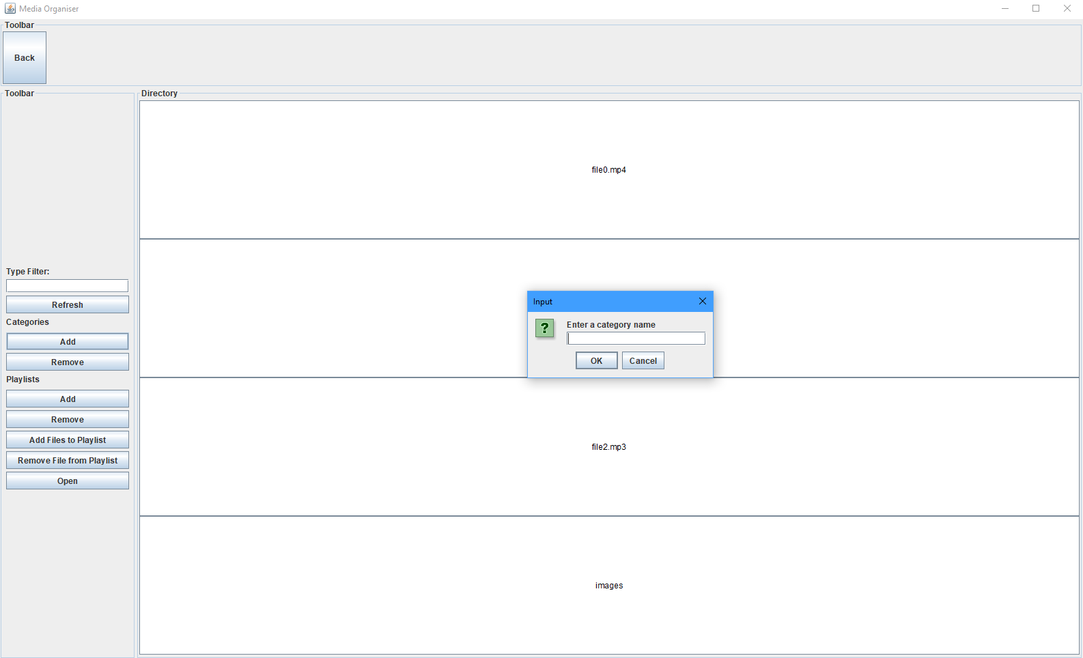

You can view a list of categories you have created under the ‘Categories’ label, also on the left toolbar, as seen below.

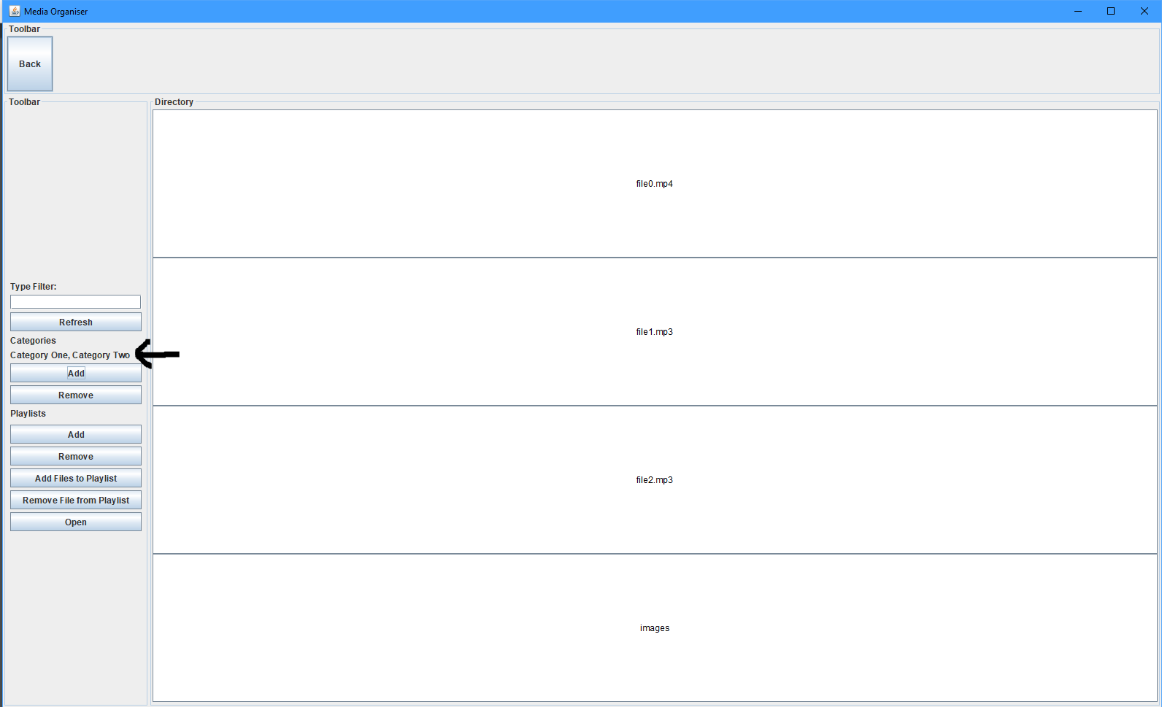

To add a category to a file, you first need to select a file. This is done by clicking on a file, which will then be highlighted in black. A new toolbar on the right will appear, from which you can click ‘Add’, which will bring up an input box with a dropdown that includes all categories you have made before this.

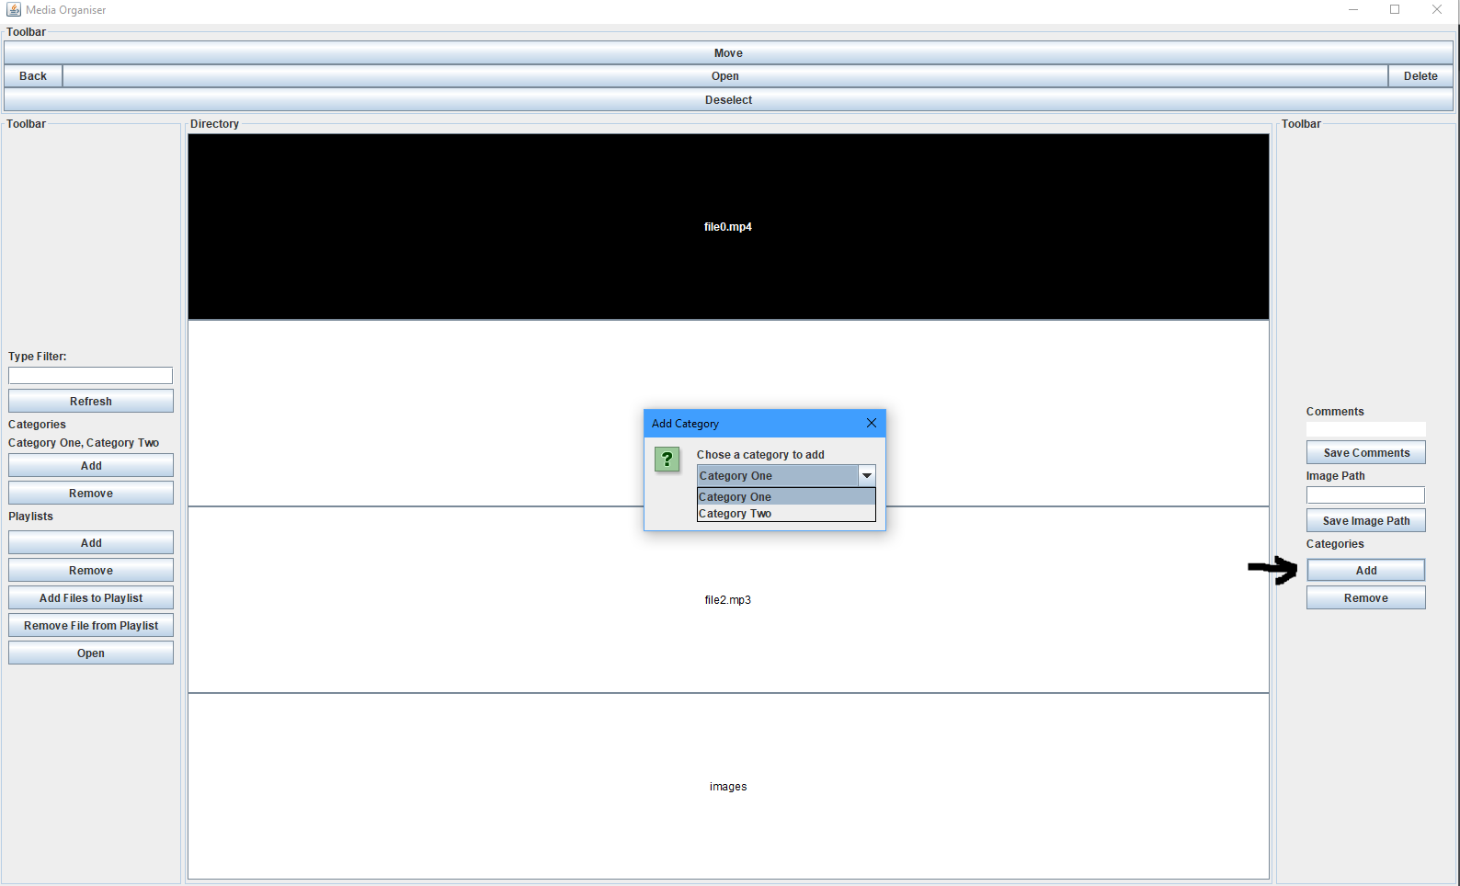

Once you have selected the desired category, click ‘OK’ and this will appear above the ‘Add’ button on the right.

Removing categories is done in the same way, but clicking the ‘Remove’ button on the right, found under the ‘Add’ button, instead.

Playlists can be created in a similar way to categories, using the buttons provided under the Playlists section on the left toolbar. Once created, files may be added to these by selecting a file, then clicking ‘Add Files to Playlist’. This will bring up a dropdown box, where you can select the playlist you wish to add the file to.

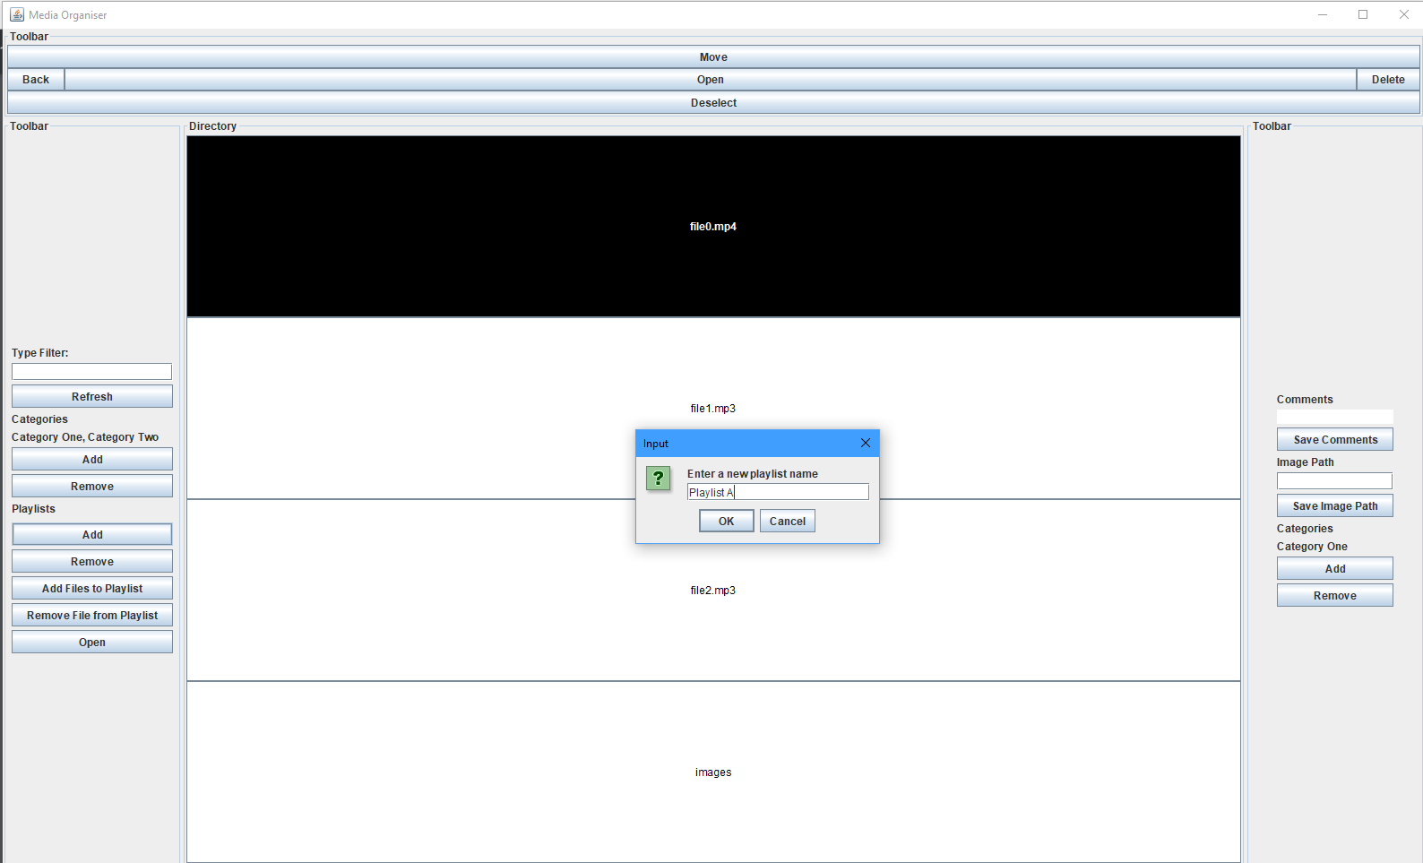

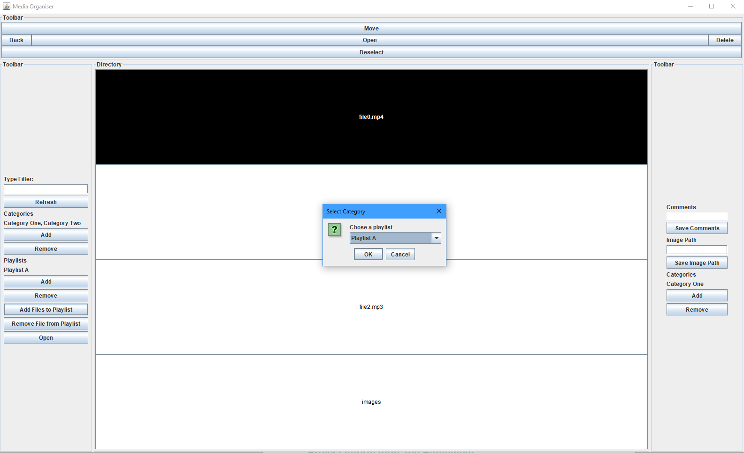

Once you have added the desired files to the playlist, you can open the playlist by clicking ‘Open’ at the bottom of the playlists section. This will give you a selection of the playlists you can open. Clicking ‘OK’ will then only show the files in that playlist in the main panel.

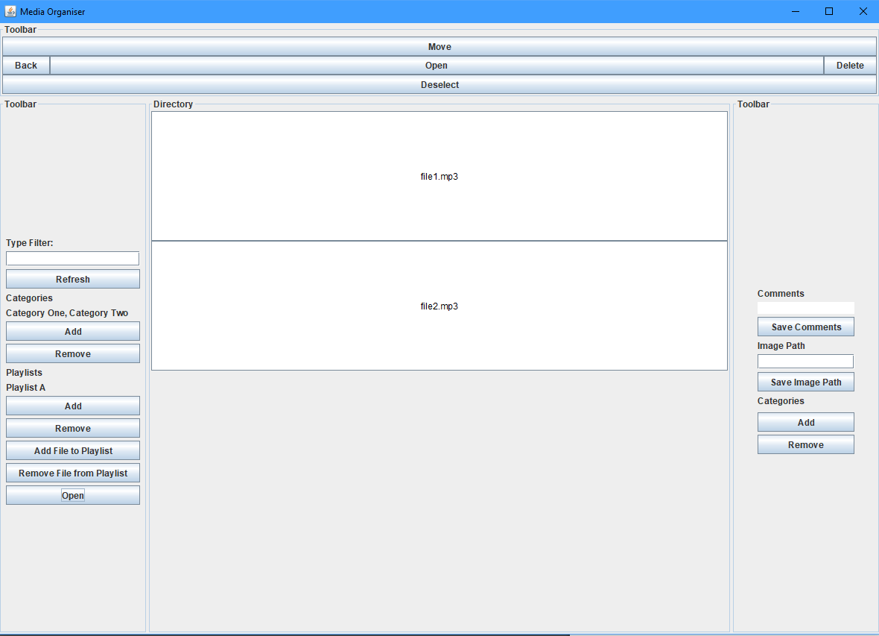

Searching by media types can be done from any directory or playlist. To do this, simply type the file extensions you want to filter by, comma separated, into the ‘Type Filter’ box on the left toolbar. Hitting refresh will then apply that filter to the current playlist or screen, but the filter will be applied to all future directories and playlists automatically when you open them, until you remove the filter. An example of a search would be “.mp4”, which would only show mp4 video files. You could also search by “.mp3,.mp4” which would show both mp3 and mp4 files.

Here is an example of a .mp4 search:

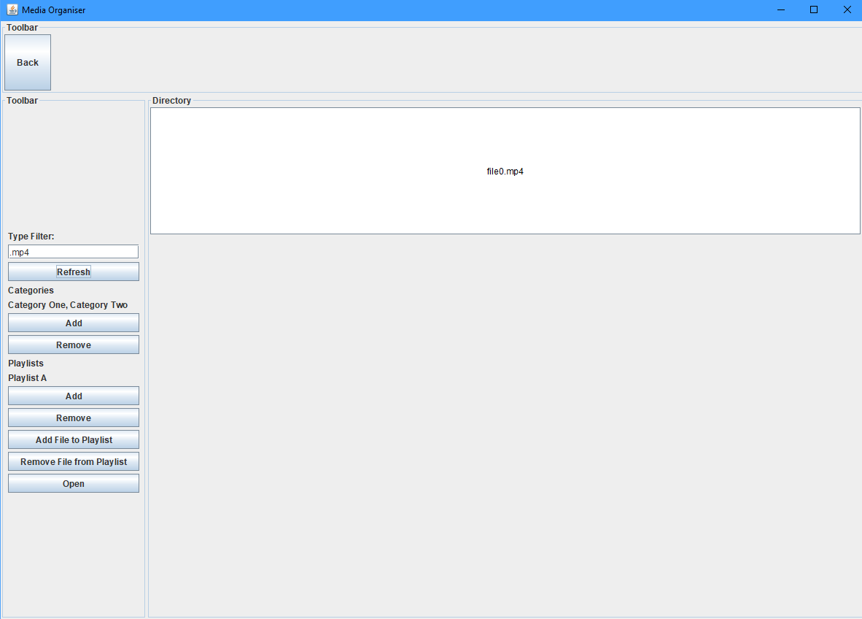

Here is an example of a .mp4 + .mp3 search:

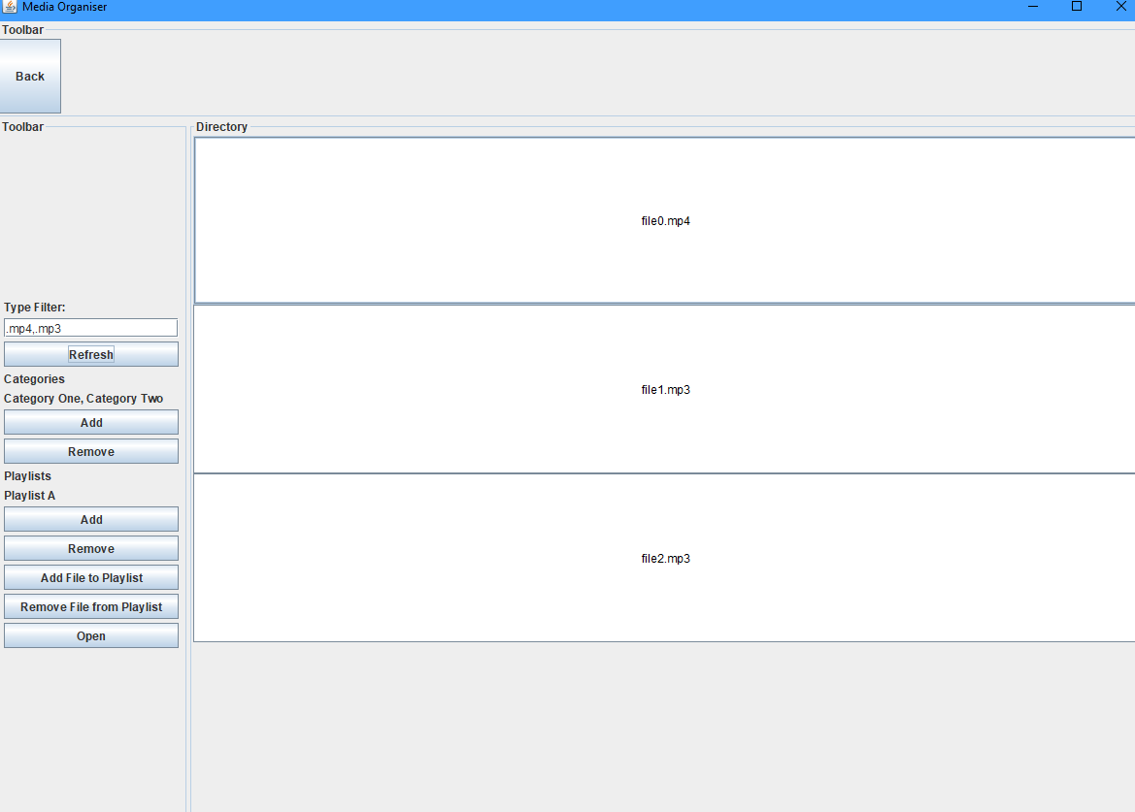

And with no search at all:

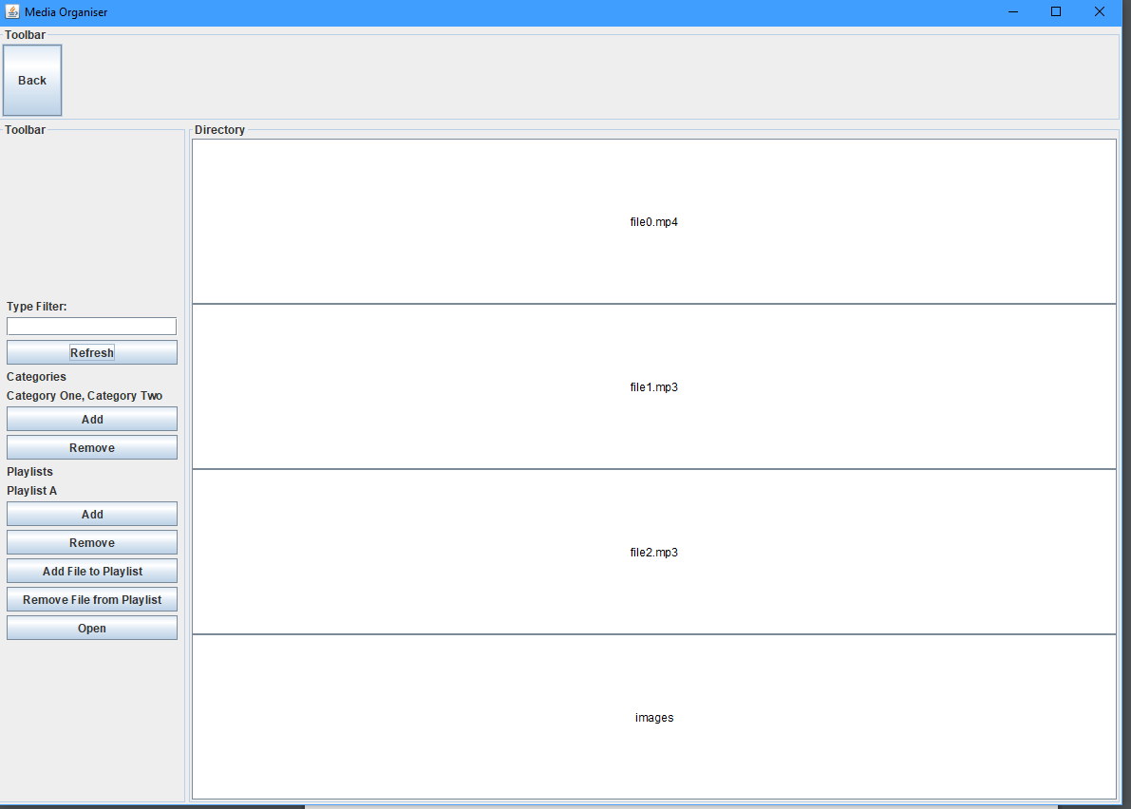

The toolbar the appears at the top of the screen when a file has been selected can be used to move, delete, open and deselect files. Moving a file is done by first clicking move, which will set the explorer in move mode, hiding the top toolbar and showing a new one at the bottom. Then, move the file, navigate to the directory in which you want the file moved, and click ‘Move Here’. Alternatively, clicking Cancel will exit move mode.

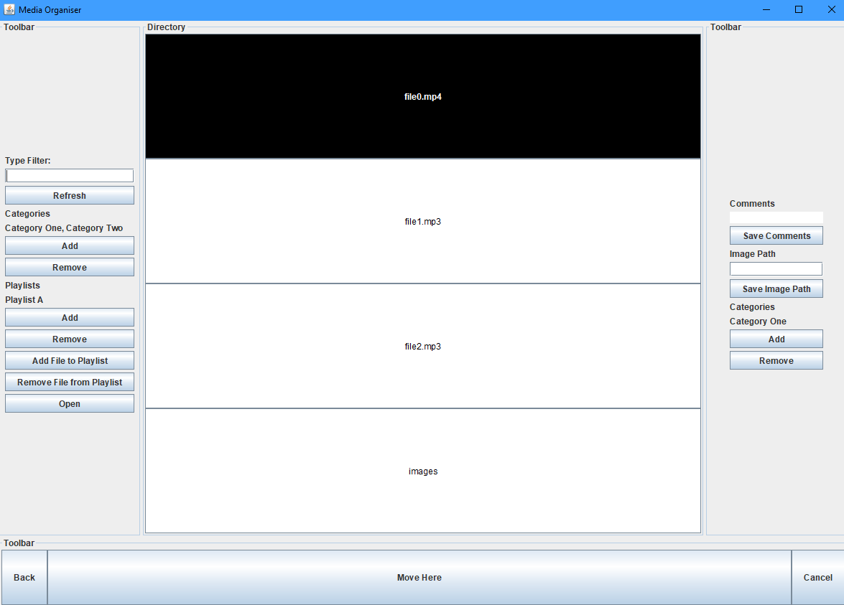

To add a comment to a file, all you need do is enter the comments in the box provided when you select a file, seen on the right panel, and click ‘Save Comments’. This will persist over multiple sessions.

In the same way, to change a media file’s button to show an image instead of the file name and extension, entering the image’s path into the ‘Image Path’ box provided, also on the right toolbar, and click save. The file should then display the image. As you can see here, I have assigned images of numbers 0 and 1 to file0.mp4, file1.mp3, but left file2.mp3 as it was.

